Question 5

Set up trunk ports between switches and try ping between different VLANs.

Approach

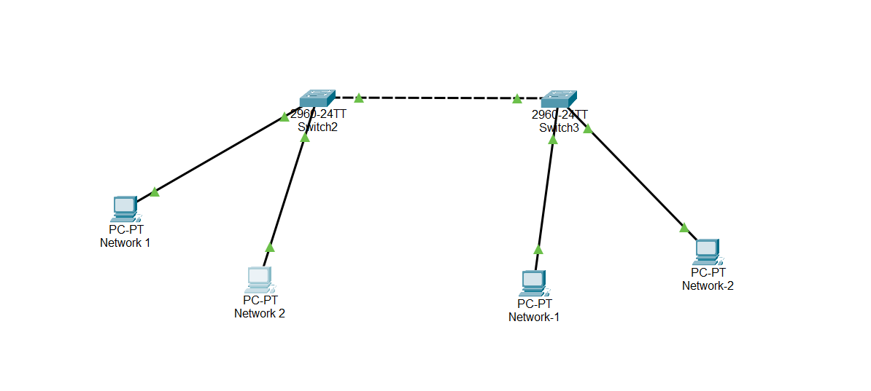

In the above network we have two VLAN Network 1 and Network 2. Our goal is to make Network 1 to communicate with network 1 on another switch but not with network 2 connected to same or another switch.

Make connection and do configuration on two switches with given command

en

conf t

vlan 10

name network1

vlan 20

name network2

exit

interface Fastethernet0/1

switchport mode access

switchport access vlan 10

interface FastEthernet0/2

switchport mode access

switchport access vlan 20

interface gigabitethernet0/1

switchport mode trunk

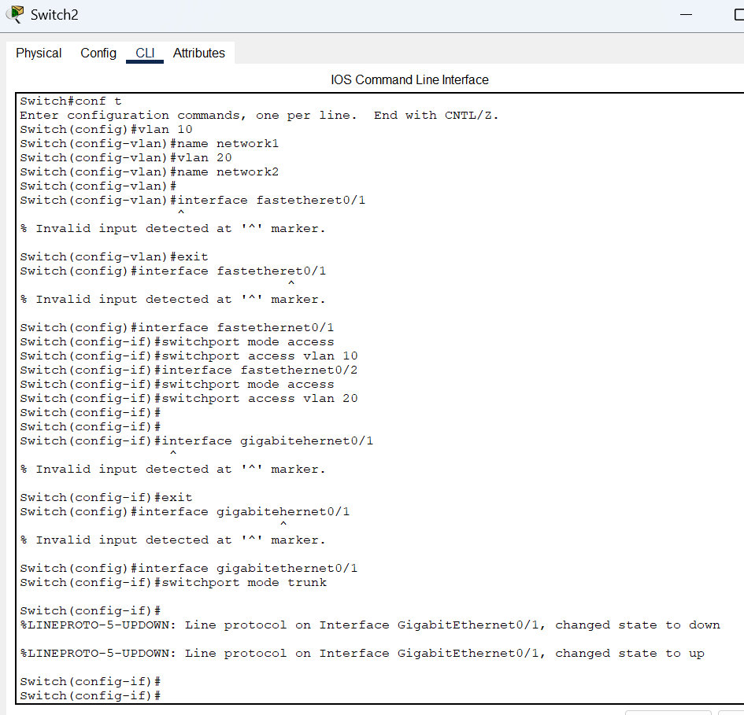

Once you done configuring two switch with above command now you can able to successfully ping network 2 on other side but not able to ping the network 1 connected to same switch

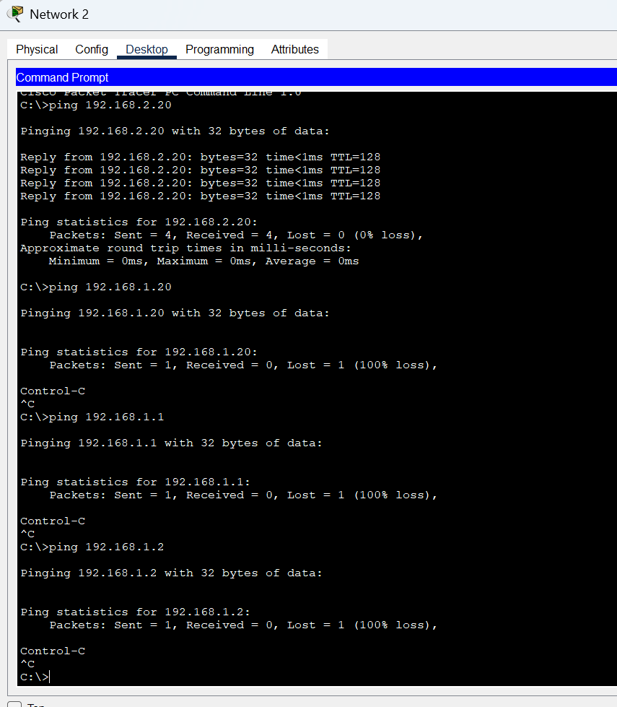

To communicate with different VLAN, we should use router or 3056 (layer 3 switch).

It will help us to do ip routing. In the above configuration as a add on go to interface of vlan and add ip address for the vlan. Do the same in both switchs. Also make ip routing available in configure terminal option. You have to do one last step. Go to gigabit interface and add switchport trunk encapsulation dot1q and allow the vlan switchport trunk allowed vlan 10,20 in both switch

